INSTRUCTION MANUAL
optical rain sensor
JXBS-3001-GXYL
VER1.0

WeihaiJXCTElectronicTechnologyCo.,Ltd.

1.Product profile
1.1 Product Overview
The optical rainfall sensor adopts the principle of optical induction to measure the rainfall, and takes the infrared light as the measurement medium. A number of optical probes are built-in to avoid the detection interference of the external light and the fog water, making the measurement results more accurate.With traditional mechanical sensors, optical rainfall is small, high sensitivity, intelligent and easy to maintain.Both 485 output and 5V pulse output are supported.
1.2 Main parameter
Parameters | Qualification
Accuracy | ≤5%
Resolution | 0.1mm
Maximum instantaneous rainfall | 0.4mm/s
Rain diameter | 4.7CM
Potter rate | 2400/4800/9600
Output mode | RS485/5V pulse output
Power supply | 12V-24V DC
Power consumption | ≤0.2W（12V DC , 25℃）
Work temperature | -30℃ 至 +50℃
Work humidity environment | 0%-99%RH（Relative humidity), non-condensation
Working pressure range | standard atmosphere ± 10%
Device mounting dimensions | 6.2-8.0CM
Overall dimensions | 75.94*64*45.5mm（Long * wide * high）
1.3 Product appearance and size
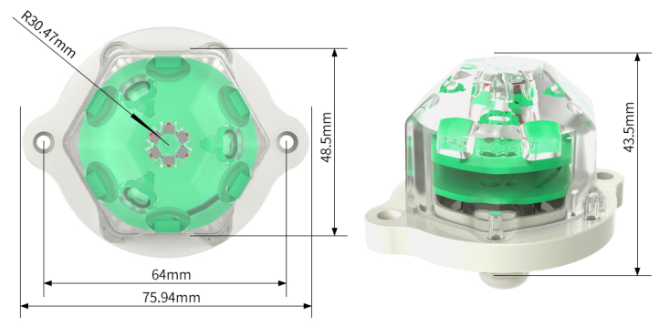

2.Hardware connection
2.1 Check the equipment before installation

Name | Number
Optical rainfall sensor | One
12V waterproof power supply | 1 (Optional)
USB to 485 equipment | 1 (Optional)
Warranty card / qualification certificate | One
2.2 Interface specification
The wide voltage supply input 12-24V. During 485 signal line wiring, A/B lines can not be connected and the address between multiple devices on the bus can not be conflicting, as shown in the table:
 | Line color | instruction
Power supply  Communication | Brown color | Power supply is positive (12-24VCC)
Power supply  Communication | Black in color | Negative power supply
Power supply | Yellow (grey) color | 485-A
Power supply | Blue in color | 485-B
Power supply | White in color | 5VPulse output port

Note:

Be careful not to connect the wrong line order, the wrong wiring will cause the equipment to burn down.

Sensors shall avoid contact with organic solvents, alcohol, coatings, oils and high concentrations of gases, also including silicone gel and other adhesives.

Senssensor cannot be used long term in environments containing corrosive gases that can damage the sensor.

It is not recommended to test sensors in unstandard methods, such as a lighter near the sensor, near alcohol, etc.

When 0.85 meters long wire is supplied by default, the customer can extend the wire or sequential wiring as required.
Assembly and installation instructions

2.3Assemblyinstructions
2.3.1 Assembly instructions 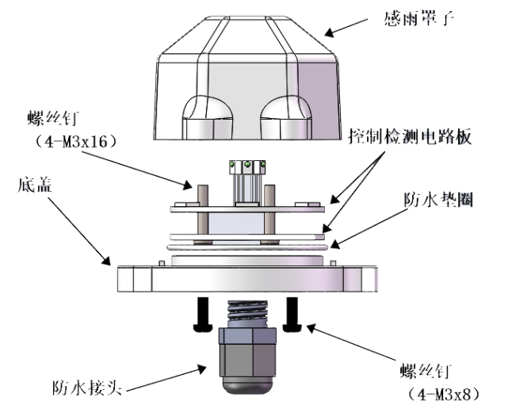
- Assembly the sensor according to the figure above and pull the waterproof washers several times during installation so that it can easily fit.Apply some waterproof silicone grease to the waterproof washers and screws.
- The rain sensor must ensure that the cover surface is dry before installation.Any water droplets can cause a measurement error.You can selectively use some desiccant inside.If the rainfall sensor can not drain the water in time, a small hole can be drilled at the bottom of the cover.
2.3.2Installation instructions
（1）Install the optical rain sensor as the correct method, place it horizontally in place, noting that there cannot be any shelter above the sensor waterproof cover, incorrect installation will lead to measurement errors.
（2）From the waterproof hole under the sensor, be sure to use the outdoor waterproof sealing wire.When fixed outdoors in the open air, please secure the product steadily, or any shaking in the sun will cause additional errors.

3.Dial-up switch description
3.1 brief introduction
The operating mode of the rainfall sensor can be selected, as well as the output function.After removing the base, you can find the code dial-up switch on the PCB surface. The code selection function can only read the configuration when electrified.
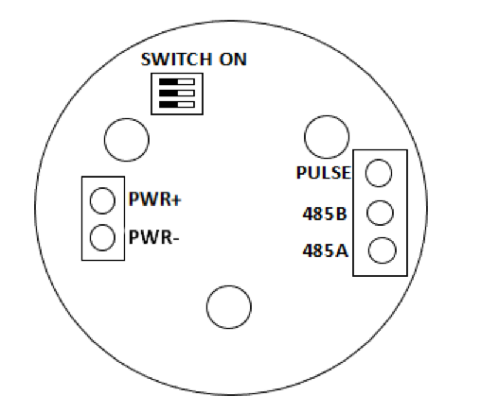

The SWITCH ON position in the figure is the dial-up switch position, which represents the b3,b2,b1. from top to bottom The operating mode of the rainfall sensor can be selected, as well as the output function.
Note: 0 represents Open (ON), 1 represents Close (OFF), and X represents anywhere
Rain measuring mode:
b1 | b2 | b3
1 | 1 | ×
A rain measurement mode produces an effective pulse for every 0.1mm of accumulated rainfall.485 Output rainfall, which can be cleared by writing 0 to the register address of 1a.
Output waveform: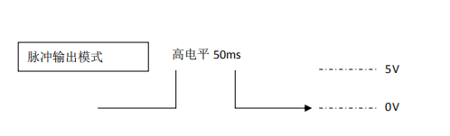
Rain mode:b1 | b2 | b3
0 | 1 | ×
Discharge waveform 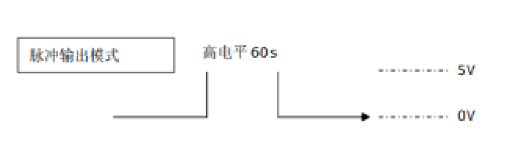In rain sensing mode, an effective pulse was output for 1 minute for about 0.05ml raindrops perceived.After 1 minute, every 10 seconds, if a rain drop is detected, otherwise the output was terminated.

4.Communicating protocol
4.1 Basic communication parameters
Parameters | Content
Cocoding | Eight-bit binary
Data bit | Eight bits
Parity check bit | None
Stop the bit | The 1-bit is available
Error calibration | CRC lengthy cycle code
The Porter rate | The 2400bps/4800bps/9600 bps is available, with a factory default of 9600bps
Code | Eight-bit binary
4.2 Data frame format definition
The Modbus-RTU general inquiry protocol is adopted in the following format:
Time of the initial structure> =4 bytes
Address code: = 1 bytes
Function code = 1 bytes
Data Zone = N bytes
Error check the = 16-bit CRC code
Time to end the structure> =4 bytes
Address code: The address of the transmitter, unique in the polling network (factory default 0x01).Function code: the command sent by the host function prompt, this transmitter only uses the function code 0x03(to read the memory data).
Data area: the data area is the specific polling area, noting that 16bits data high bytes are in frontCRC Code: A two-byte check code.
Ask about the frames
Address code | Address code | Address code | Address code | Address code
Function code | Function code | Function code | Function code | Function code
Acknowledgement frame
Address code | Address code | Address code | Address code | Address code | Address code
Function code | Function code | Function code | Function code | Function code | Function code
4.3 Register address
Register address | Register address | Register address |  | Register address
0001H | 40002 | 24 / 2 rainfall (in 0.1mm) | 24 / 2 rainfall (in 0.1mm)
0003H | 40004 | Read-only | Read-only
0105H | 40106 | Rainfall (in 0.1mm) | Rainfall (in 0.1mm)
0100H | 40101 | Read-only | Read-only
0101H | 40102 | Clear the rain to zero | Clear the rain to zero
4.4 Communication protocol examples and interpretation
4.4.1 Read the rainfall value of the device address, 0x01
Ask the frame
Address code | Address code |  | Address code |  | Address code |  | Address code |  | Address code
0x01 | 0x03 |  | 0x00,0x03 |  | 0x00,0x01 |  | 0x74 |  | 0x0A
Address code |  | Address code |  | Address code |  | Address code |  | Address code |  | Address code
0x01 |  | 0x03 |  | 0x02 |  | 0x00,0x03 |  | 0xF8 |  | 0x45

Rainfall:

0003 H(hexadecimal) =3=> rainfall =0.3mm
4.4.2 Manual clear the rainfall at the equipment address 0x01
Ask the frame
Address code | Address code | Address code | Address code | Address code | Address code
0x01 | 0x06 | 0x00,0x105 | 0x00,0x00 | 0x98 | 0x37
Acknowledgement frame
Address code | Address code | Address code | Address code | Address code | Address code
0x01 | 0x06 | 0x00,0x105 | 0x00 0x00 | 0x98 | 0x37

Note: The rain is automatically started and recalculated after each outage. The rain within 24 hours is automatically cleared after 24 hours and power-off.

